NAME ABHILASH PATYAL
REG NO 11804187
EMAIL ID abhilashpatyal15@gmail.com
GITHUBID https://github.com/abhilashpatyal15

Ques 4

Code:
#include<iostream>
#include<thread>
#include<chrono>
using namespace std;
using namespace std::chrono;
void fib(int n)
{
int *arr=new int [n];
arr[0]=0;
arr[1]=1;
if(n==1){
cout<<"element"<<arr[0]<<" is generated and stored in array"<<"\n";
}
else if(n==2){
cout<<"element "<<arr[0]<<" is generated and stored in array"<<"\n";
cout<<"element "<<arr[1]<<" is generated and stored in array"<<"\n";
}
else
{
cout<<"element "<<arr[0]<<" is generated and stored in array"<<"\n";
cout<<"element "<<arr[1]<<" is generated and stored in array"<<"\n";
for(int i=2;i<n;i++)
{
int element=arr[i-1]+arr[i-2];
arr[i]=arr[i-1]+arr[i-2];
cout<<"element "<<element<<" is generated and stored in array"<<"\n";
}
cout<<"======================================================= ======================"<<endl;
cout<<"The resultant fibonacci series is"<<endl;
for(int i=0;i<n;i++)
{
cout<<arr[i]<<" ";
}
cout<<endl;
cout<<"============================================================ ================="<<endl;
}
}
int main()
{
int n;
cout<<"enter a number to print fibonacci"<<"\n";
cout<<"======================================================= ======================"<<endl;
cin>>n;
cout<<"======================================================= ======================"<<endl;
cout<<"======================================================= ======================"<<"\n";
auto starttime = high_resolution_clock::now();
std::thread t1(fib,n);
t1.join();
auto stoptime=high_resolution_clock::now();
auto duration=duration_cast<microseconds>(stoptime-starttime);
cout<<endl;
cout<<"============================================================================="<<endl;
cout<< "Time taken in execution in sec: "<<duration.count()/1000000<<endl;
cout<<"============================================================================="<<endl;
return 0;
}

SCREENSHOTS
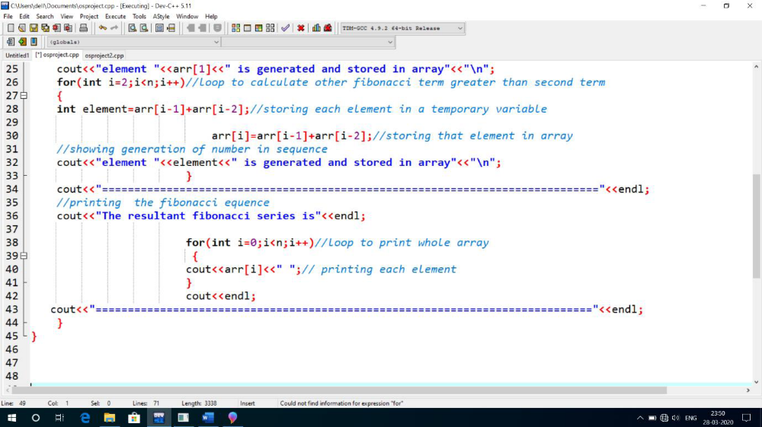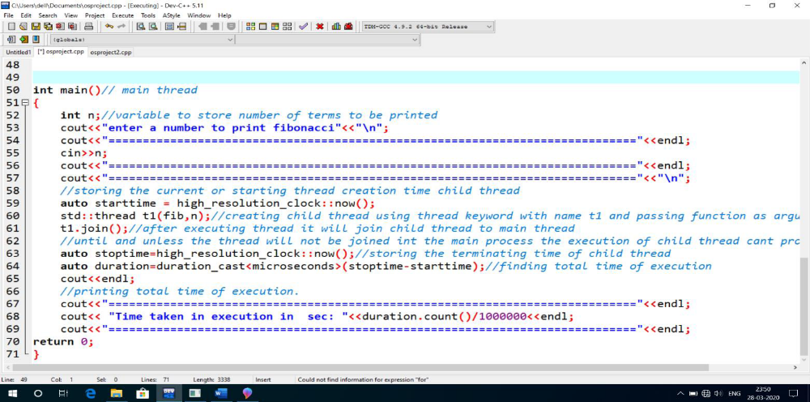KJJK,BN,B,M MLM ,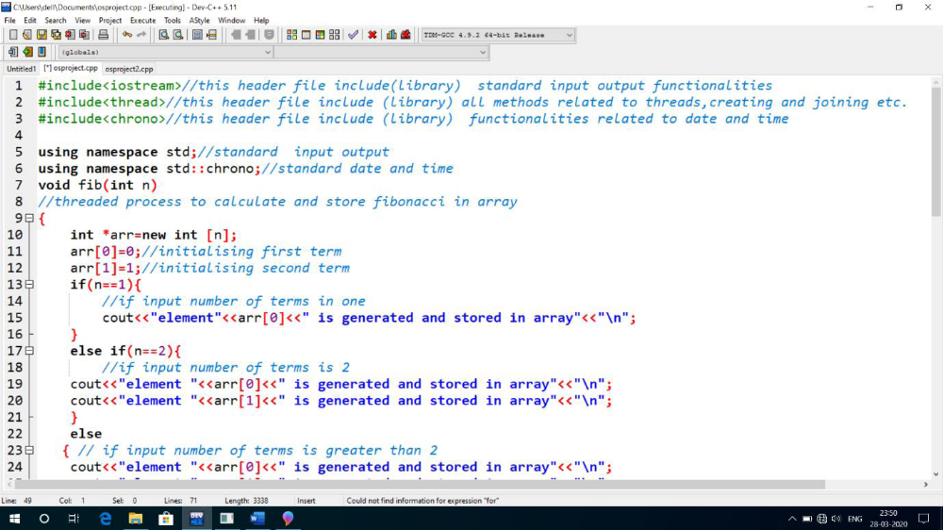

Input constraints:-To check correct functionalities of program please enter the number of terms less than 48;
***** 0< N < 48******
Output screen will be shown like and follow these below three images to get the output procedure.
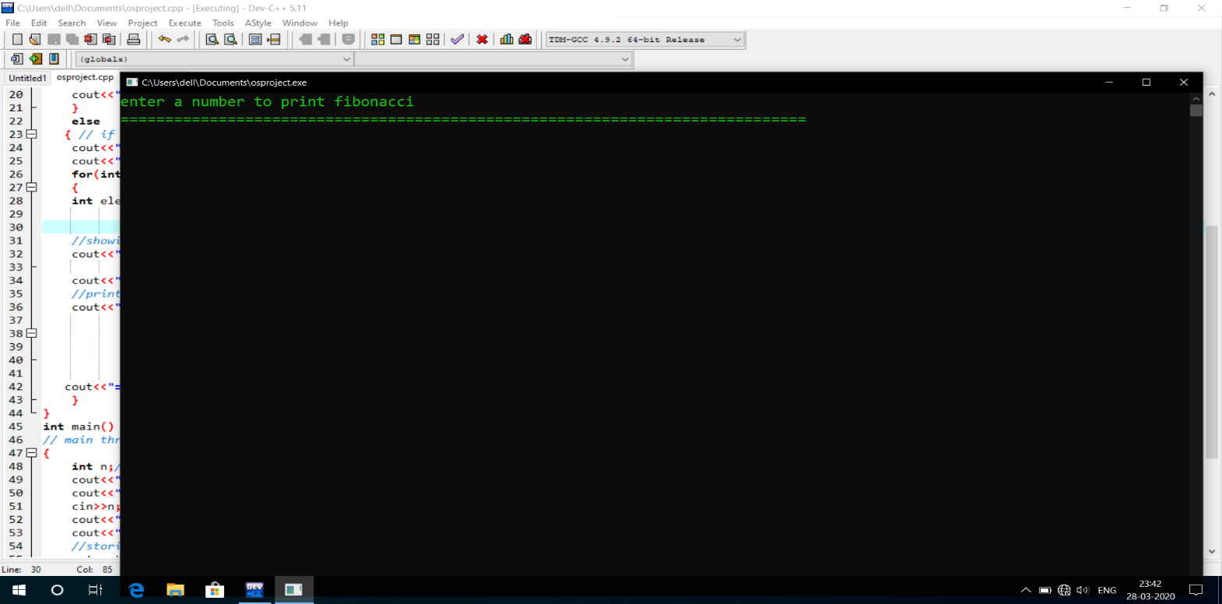

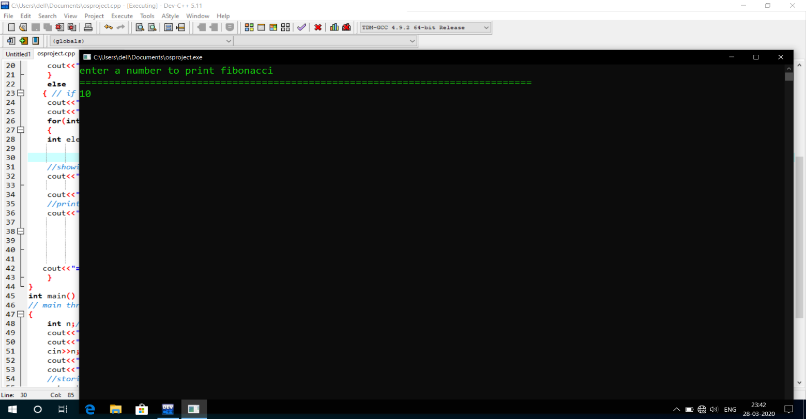

Finally the below image will show the output .
FFinally the below image will show the output .

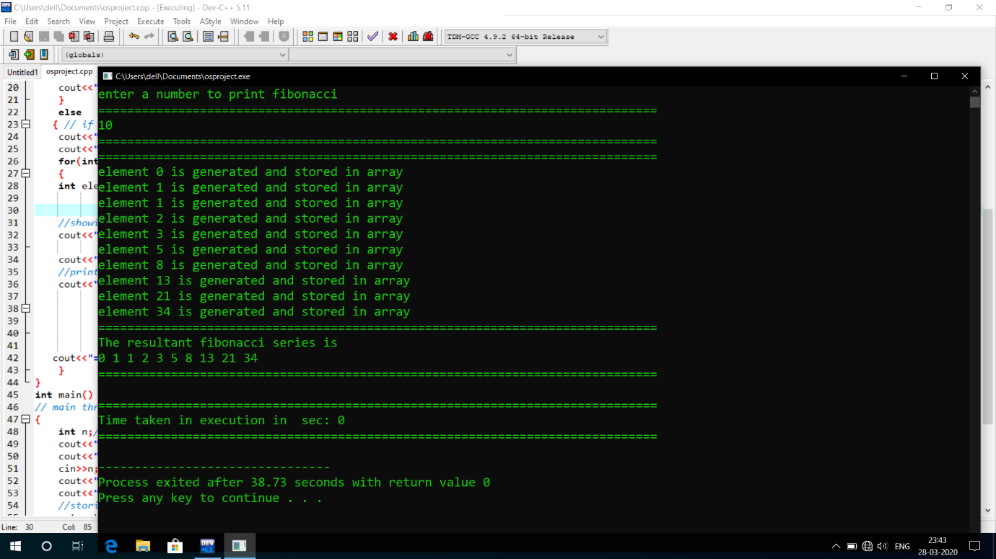
1.Problem explanation : -
The problem given is to generate a Fibonacci sequence till a given terms. Fibonacci numbers are the numbers with two predefined terms i,e first term is zero and second term is one after that we calculate the sequence with help of these two terms .Except these two terms the each next terms are calculated by adding its previous two terms .For example if first term is 0 and second term is one then third term will be first term + second term i,e 0+1=1 and same pattern is followed for calculating other desired number of terms. An array is most suited Data structure to store element of series because of its serial nature.
The problems says that implement it with concept of multithreading , So multithreading is a concept of operating system in which there is a main process or more specifically we call it parent process ,then a parent process create a another process called child process and control goes to child process. A thread is a lightweight process .
A thread is a path which is followed during a program’s execution. Majority of programs written now a days run as a single thread. Lets say, for example a program is not capable of reading keystrokes while making drawings. These tasks cannot be executed by the program at the same time. This problem can be solved through multitasking so that two or more tasks can be executed simultaneously.
Multitasking is of two types: Processor based and thread based. Processor based multitasking is totally managed by the OS, however multitasking through multithreading can be controlled by the programmer to some extent.
The concept of multi-threading needs proper understanding of these two terms – a process and a thread. A process is a program being executed. A process can be further divided into independent units known as threads. A thread is like a small light-weight process within a process. Or we can say a collection of threads is what is known as a process.
Advantage :- Make less burden on CPU .
Program execution become faster.
Multiple process
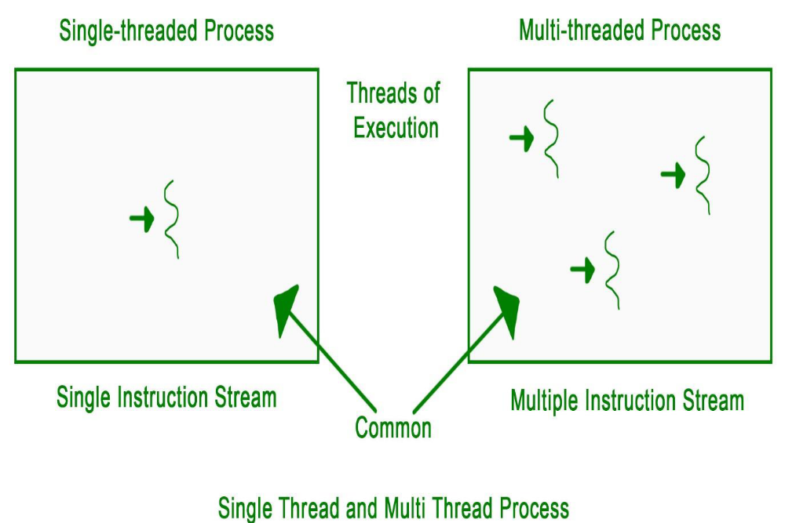

Advantage :- Make less burden on CPU .
Program execution become faster.
Multiple process can run at a time.
Example :- When we open our code editor the a thread is created which run side by side and produce matching word , keywords ,suggestion and in some advance editor it also report errors side by side ,for instance Sublime text and intellij IDEA community edition.
2.Algorithm complexity -All lines in code not involving any loop have complexity of constant time and those which are involving loop are having complexity O(n) beacuse there is only normal loop and no any nested loop.
So complexity:- O(n)+c which in terms imply to be O(n).
Space complexity is constant because a dynamic array is created and and whole calculation is done using that array only ,So this is an In place algorithm taking constant memory space.
Algorithm for Fibonacci:-
- • Start
- • Declare variables i, a,b , show
- • Initialize the variables, a=0, b=1, and show =0
- • Enter the number of terms of Fibonacci series to be printed

- • Print First two terms of series
- • Use loop for the following steps ->show=a+b ->a=b ->b=show ->increase value of i each time by 1 -> print the value of show
- • End
- • Flowchart for Fibonacci:
- •
- •
- •

LIBRARY USED
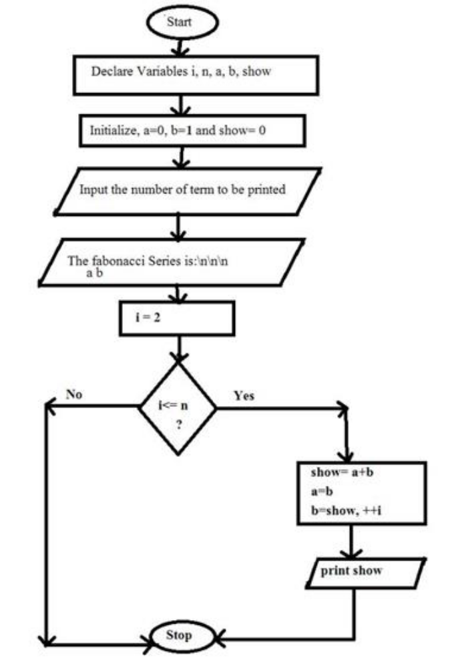

Library used
1.iostream -: for standard input and output
2.threads -: to create threads
3.chrono -: used to deal with time
Instruction to give input:
When you run the code it will ask for a number
So enter any number greater then zero whenever limit will exceed the range of data automatically get repeated
After that prigram will show the out put the adding process of numbers and finally full series.
OUTPUT Snippet
T get output like this follow the above dev C++ output image file
enter a number to print fibonacci
5
=============================================================================
=============================================================================
element 0 is generated and stored in array
element 1 is generated and stored in array
element 1 is generated and stored in array
element 2 is generated and stored in array
element 3 is generated and stored in array
=============================================================================
The resultant fibonacci series is
0 1 1 2 3
=============================================================================
=============================================================================
Time taken in execution in sec: 0
=============================================================================
--------------------------------
Process exited after 81.64 seconds with return value 0
Press any key to continue . . .
This was output format.
References for project :-
You tube for learning threading in C++;
Concepts are learned from whatever was taught by teacher and self study.

Ques 23
Code
#include <stdio.h>
#include <stdlib.h>
double page_fault_rate();
void userInput(void);

double service_page_fault_empty;
double service_page_fault_modified;
double mem_access_time;
double times_page_modified;
double effective_access_time;
double pageFaultRate;
double service_page_fault_empty_ns;
double service_page_fault_modified_ns;
double times_page_modified_per;

void main(){
int swtch;

do{

printf("Select the required option \n");
printf("1.Find the PageFault Rate\n");
printf("2.Exit");
scanf("%d",&swtch);
switch(swtch){
case 1:userInput();break;
case 2:exit(0);
}
printf("\n\n");

}while(swtch<3);
}
void userInput(){

printf("\nEnter service Page Fault [Empty|Page is not Modified][in milliseconds]");
scanf("%lf",&service_page_fault_empty);
printf("Enter Service Page Fault [Modified Page][in milliseconds]");
scanf("%lf",&service_page_fault_modified);
printf("Enter Memory Access Time[in nanoseconds]");
scanf("%lf",&mem_access_time);
printf("Enter Percentage of time the page to be replaced is modified[0-100]");
scanf("%lf",&times_page_modified);
printf("Enter Effective Access time[in nanoseconds]");
scanf("%lf",&effective_access_time);

service_page_fault_empty_ns = (service_page_fault_empty*1000000);
service_page_fault_modified_ns = (service_page_fault_modified*1000000);
times_page_modified_per = (times_page_modified/100);
printf("\nPage Fault rate calculated For:\n");
printf("Service Page Fault[Empty|Page Not Modified]=%lf \n",service_page_fault_empty_ns);
printf("Service Page Fault [Modified Page][in nanoseconds] %lf \n",service_page_fault_modified_ns);
printf("Memory Access Time[in nanoseconds]%lf\n",mem_access_time);
printf("Effective Access Time %lf\n",effective_access_time);
pageFaultRate = page_fault_rate(service_page_fault_empty_ns,service_page_fault_modified_ns,mem_access_time,times_page_modified_per,effective_access_time);
printf("\nMaximum Acceptable Page Fault rate = %.2e[exponential notation]",pageFaultRate);

}

double page_fault_rate(double servicePageFaultEmpty,double servicePageFaultMod,double memAccess,double timesPages,double effAccess){
double assume,serve;
double numErator,denOminator;
double pageFault;
assume = (1- timesPages)*servicePageFaultEmpty;
serve = timesPages*servicePageFaultMod;
numErator = effAccess - memAccess;
denOminator = (assume+serve);

pageFault = numErator/denOminator;
return pageFault;

}
Screenshots
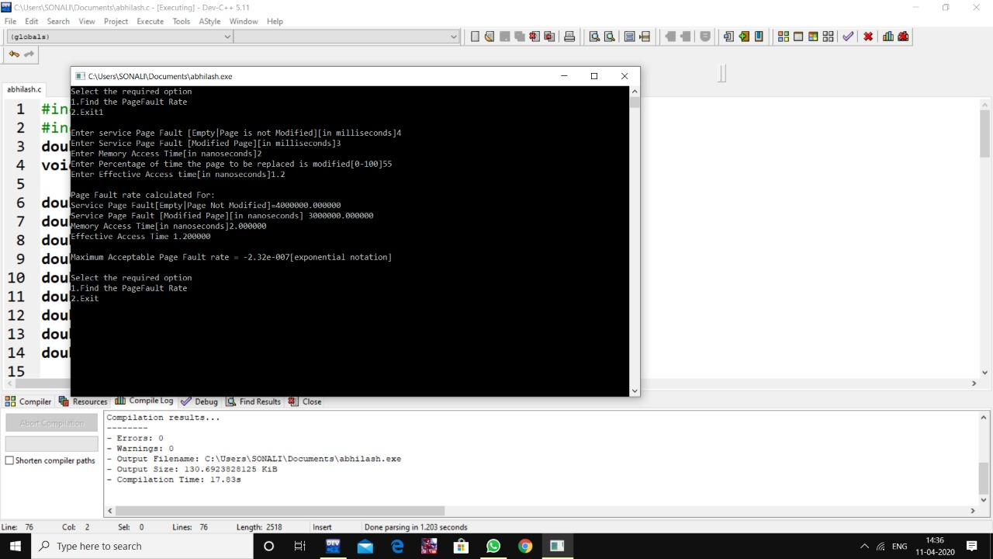

We know how to find an effective access time (EAT) for a given page-fault rate (p).
Here, we have to find 'p' for given 'EAT' so we set up the following equation and solve for 'p':
(Note: 1 millisecond = 1,000,000 nanoseconds = 1e6 nanoseconds)
Time taken to service page Fault for empty page or unmodified page = 8ms.
Time taken to service page Fault for modified page = 20ms
Memory access time = 100ns
Effective Access time = 200ns
EAT = (1-p)(100) + (p)(100 + (1-.7)(8msec) + (.7)(20msec))
= 100 - 100p + 100p + (2.4e6)*p + (14e6)*p
= 100 + (16.4e6)*p
200 = 100 + (16.4e6)*p
p = 100/16.4e6 = 6.0975609756097560975609756097561e-6 ~ 6.01e-6
p-->page Fault Rate
complexity
0(n)+c

Submitted to CSE 316 Faculty:- Respected shivali chopora ma’am;
Last date for submission 11 march 2020;
Submitted before last date.
Additional information :
Section KI8TS

